NPFC-2025-FAC07/TCC08/COM09-MIP01

**DETAILS FOR THE 7th FINANCE AND ADMINISTRATION COMMITTEE, 8th TECHNICAL AND COMPLIANCE COMMITTEE AND**

**9th COMMISSION MEETINGS**

**18 – 27 March 2025**

**Osaka, Japan (hybrid)**

The 7th Finance and Administration Committee meeting, the 8th Technical and Compliance Committee meeting, and the 9th Session of the Commission will be held in Osaka, Japan from 18-27 March 2025. To facilitate your travel arrangements, the Secretariat (as organizer for these sessions) has prepared information for your reference as below.

1. Dates
2. Meeting Venue
3. Meeting Pre-Registration
4. Visa Information
5. Border Measures
6. Accommodation Guide and Map
7. Transportation from Osaka arrival points to the Meeting Venue
8. Arrival at the Meeting
9. Social Events
10. Other Information

# Dates

The meetings commence on 18 March 2025 and carry on through to 27 March 2025 as follows:

* 8th Technical and Compliance Committee (TCC08), 18-21 March 2025,
* 7th Finance and Administration Committee (FAC07), 22 March 2025,
* Head of Delegation (HOD), 24 March 2025 (8h 30), and
* 9th Commission meeting (COM09), 24-27 March 2025.

# Meeting Venue

The meetings will be held at the [Namba Midosuji Hall](https://nanbamidousujihall.com/).



Main venue, Secretariat's office and small meeting rooms are outlined in the table below.

Google map: <https://maps.app.goo.gl/dGUgr5oZKeGgpAuH7>

（a）Main meeting room

|  |  |  |  |  |  |
| --- | --- | --- | --- | --- | --- |
| Month | Date | Day | Meeting | Floor | Room |
| March | 18 | Tue | TCC | 6 | Hall 6 |
| 19 | Wed |
| 20 | Thu |
| 21 | Fri |
| 22 | Sat | FAC | 6 | Hall 6 |
| 23 | Sun | No formal meetings |  |  |
| 24 | Mon | COM | 6 | Hall 6 |
| 25 | Tue |
| 26 | Wed |
| 27 | Thu |

（b）Secretariat office

|  |  |  |  |  |
| --- | --- | --- | --- | --- |
| Month | Date | Day | Floor | Room |
| March | 18 | Tue | 8 | Hall 8C |
| 19 | Wed |
| 20 | Thu |
| 21 | Fri |
| 22 | Sat |
| 23 | Sun |
| 24 | Mon |
| 25 | Tue |
| 26 | Wed |
| 27 | Thu |

（c）Small meeting room – Please see Secretariat to book.

|  |  |  |  |  |
| --- | --- | --- | --- | --- |
| Month | Date | Day | Floor | Room |
| March | 18 | Tue | 8 | Hall 8B |
| 19 | Wed |
| 20 | Thu |
| 21 | Fri |
| 22 | Sat |
| 23 | Sun |
| 24 | Mon |
| 25 | Tue |
| 26 | Wed |
| 27 | Thu |

# 3. Meeting Pre-Registration

# Online pre-registration for TCC, FAC and COM participants is on the NPFC website <https://www.npfc.int/meetings> and is now available[.](http://www.npfc.int/) Please log in to your NPFC account and register by 7 March 2025.

The meeting will be organized as an in-person meeting but remote participation via Webex will be possible. Please indicate in the registration process if you will attend in-person or on-line. We note that your participation type may be different for different meetings so please indicate this in your registration.

**4. Visa Information**

Please access the webpage of Japan consular services from the link below to determine if you need a visa to enter Japan.

Link: <https://www.mofa.go.jp/j_info/visit/visa/index.html>

An official invitation letter is essential for some participants to apply for a Japanese visa. Each delegation that applies for a Japanese visa is kindly requested to provide the information in **Attachment 1** to the meeting coordinators, Mr. Yukiya Uchida (yukiya_uchida230@maff.go.jp) and Mr. Kenichi Ono (kenichi_ono250@maff.go.jp), **by 4 February 2025** to facilitate issuance of the invitation letters from Japan for visa purposes. Please respect the deadline to allow for the necessary visa application processing time.

If you have any questions regarding *visas*, please do not hesitate to contact:

Mr. Yukiya Uchida at yukiya_uchida230@maff.go.jp or by phone at +81-03-3591-1086, or

Mr. Kenichi Ono at [kenichi_ono250@maff.go.jp](mailto:kenichi_ono250@maff.go.jp)

**5. Border Measures**

Since 29 April 2023, valid vaccination certificate or a pre-arrival test is not required to enter Japan.

Current Japanese Border Measures (<https://www.mhlw.go.jp/stf/covid-19/bordercontrol.html>)

To facilitate entry procedures to Japan, please visit this VisitJapan website (<https://vjw-lp.digital.go.jp/en/>)

# 6. Accommodation Guide and Map

Each participant is responsible for making his or her own hotel arrangement. You are **strongly encouraged** to make your reservations early due to limited room availability for the duration of the meetings to avoid having to move rooms/hotels.

|  |  |  |  |
| --- | --- | --- | --- |
| **Table. Recommended Hotels near the Meeting Venue** | | | |
| **No.** | **Hotel Name** | **Access to the Meeting Venue** | **Address and Telephone Number** |
| 1 | [Hotel Royal Classic](https://hotel-royalclassic.jp/) | 2 minute walk  (140 m) | Address: 4-3-3 Namba, Chuo-ku, Osaka-shi, Osaka 542-0076, Japan  Tel.: +81- 6-6633-0030 |
| 2 | [Grids Premium Osaka Namba](https://gridshotel.com/osaka-namba/en/) | 4 minute walk  (300 m) | Address: 1-7-7 Nanbanaka, Naniwa-ku, Osaka-shi, Osaka 556-0011, Japan  Tel.: +81- 6-6641-5801 |
| 3 | [Namba Oriental Hotel](https://nambaorientalhotel.co.jp/) | 6 minute walk  (400 m) | Address: 2-8-17, Sennichi-Mae, Chuo-Ku, Osaka-shi, Osaka 542-0074, Japan  Tel.: +81-6-6647-8111 |
| 4 | [Hotel Ilcuore Namba](https://www.ilcuore-namba.com/en/) | 6 minute walk  (400 m) | Address: 1-15-15 Namba-Naka, Naniwa-ku, Osaka-shi, Osaka 556-0011, Japan  Tel.: +81- 6-6647-1900 |
| 5 | [Hotel Monterey Grasmere Osaka](https://www.hotelmonterey.co.jp/en/grasmere_osaka/) | 7 minute walk  (500 m) | Address: 1-2-3 Minatomachi, Naniwa-ku, Osaka-shi, Osaka 556-0017, Japan  Tel.: +81-6-6645-7111 |
| 6 | [Hiyori Hotel Osaka Namba Station](https://namba.hiyori-hotel.jp/lang_en/) | 8 minute walk  (500 m) | Address: 3-1-2 Nambanaka, Naniwa-ku, Osaka-shi, Osaka 556-0011, Japan  Tel.: +81-6-6643-5280 |

Map. Meeting Venue and the Recommended Hotels

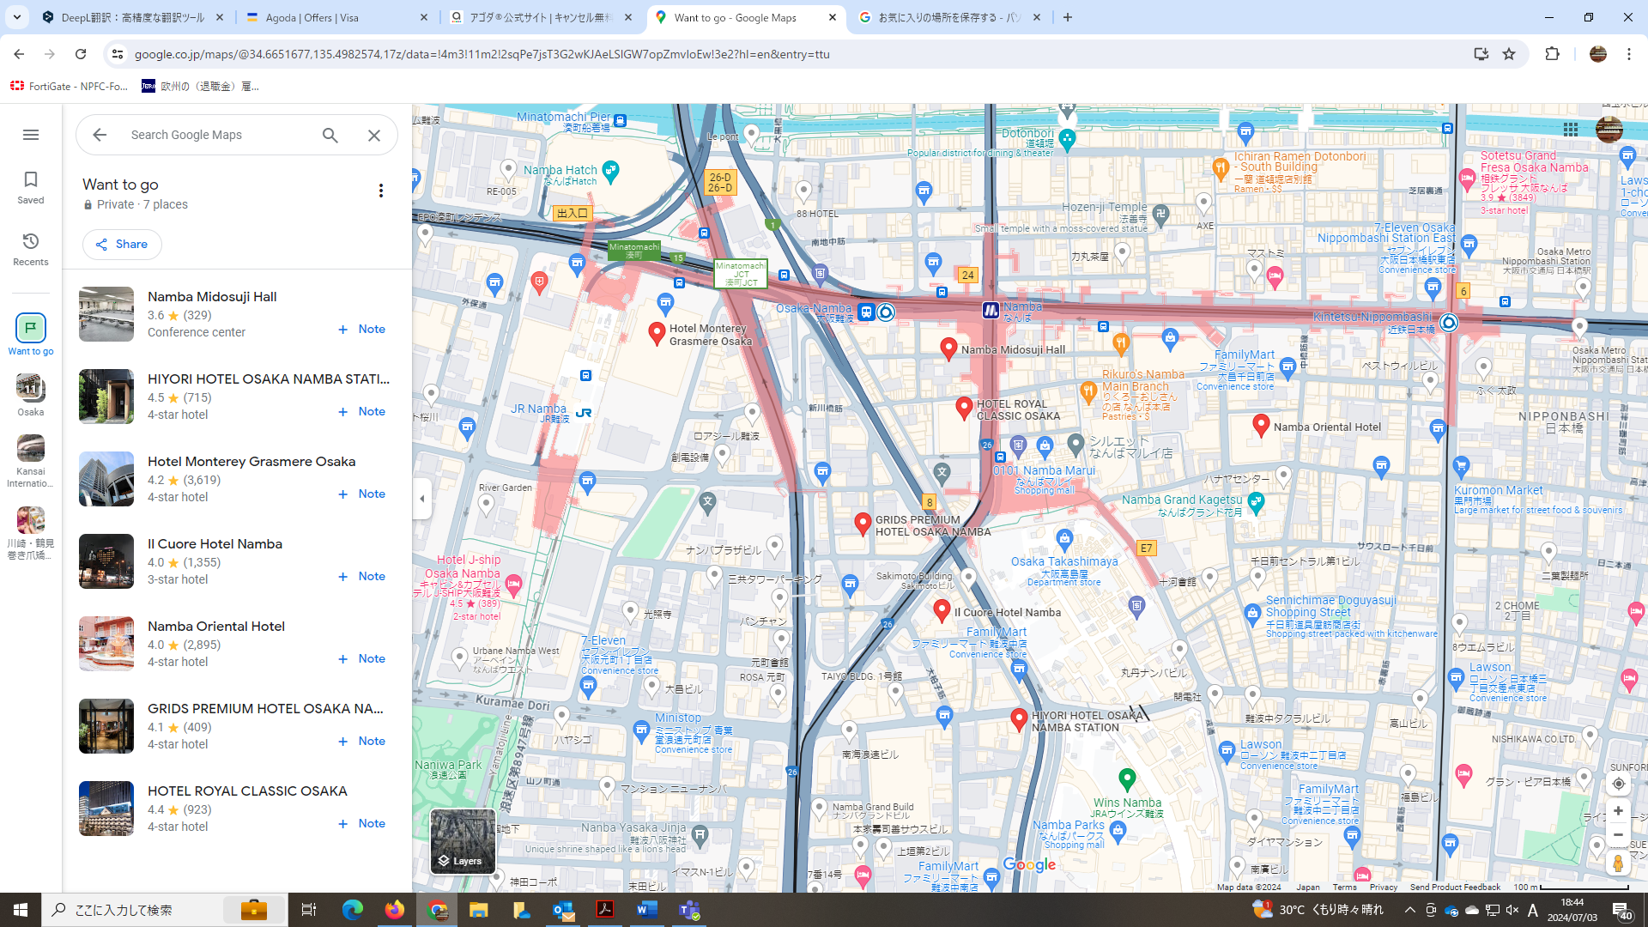

------------

------------

------------

------------

------------

------------

------------

------------

In addition to the above, some other Japanese business hotels nearby can be found as follows:

7. [Natural Hot Spring Midosuji Hotel](https://www.bhsg.jp/midosuji/)

8. [Forz Hotel Kintetsu Osaka-Namba](https://www.kintetsu-re.co.jp/zzzzhotel/osaka-namba/english/)

9. [Sotetsu Fresa Inn Osaka-Namba](https://sotetsu-hotels.com/en/fresa-inn/namba-ekimae/)

10. [Toyoko Inn Osaka-Namba](https://www.toyoko-inn.com/eng/search/detail/00351/)

There are many hotels near the meeting venue. Hotels to the south of Namba Station are recommended.

*15 single rooms have been blocked at the Namba Oriental Hotel and available on a first come basis until 15 February 2025. If you would like to book one of these rooms please contact the NPFC Executive Assistant Ms. Yuko Takamiya at* [*ytakamiya@npfc.int*](mailto:ytakamiya@npfc.int)*. The room charge will be 26,400 JPY/night from 17 to 21 March 2025 and 31,400 JPY/night from 22 to 28 March 2025 (+Tax).*

**7. Transportation from Airports to the Meeting Venue/Your Hotel**

by Air:

Itami Airport > (25 minutes by Limousine bus) > Namba Station > (5 min walk) > Meeting Venue

Kansai Int’l Airport > (38 min by Nankai train) > Namba Station > (5 min walk) > Meeting Venue

Kansai Int’l Airport > (44 min by JR train) > JR Namba Station > (5 min walk) > Meeting Venue

by Shinkansen :

JR Shin-Osaka Station > (15 min by subway) > Namba Station > (1 min walk) > Meeting Venue

Travel to the listed hotels may be through Namba Station unless your hotel offers a shuttle bus.

**8. Arrival at the Meeting**

Pre-registration using your NPFC account is required in advance of the meeting (<https://www.npfc.int/meetings>) and is now available.

Meeting packages and name-tags (required to access the meeting room) will be available to registered delegates outside the TCC, FAC or COM plenary room at the following times:

* 8th TCC meeting (18 March) – from 08:30 to 09:00 a.m.
* 7th FAC meeting (22 March) – from 08:30 to 09:00 a.m.
* 9th Commission meeting (24 March) – from 08:30 to 09:00 a.m.

If this registration time is not convenient for you, please ask the Secretariat staff for alternate arrangements..

**9. Social Events** [UPDATED]

Reception:

* *18 March, 18:30-20:30 p.m., location; Hotel Royal Classic Osaka, Room; HANAMEI(8F)., reception hosted by Fisheries Agency of Japan.*
* *24 March, 19:00-21:00 p.m., location; The Garden Oriental Osaka, Room; The Oriental Park Room, reception hosted by NPFC*

Group Activities : *Futsal event and Sakana Festival(Seafood Festival)*

* *Futsal; 23 March, 10:00~12:00 am., location;*  *Captain Tsubasa Stadium Ikuno (A-court)., (meeting, 9;30., the front of Namba Midosuji Hall)*
* *After Futsal, or on your own, lunch on Japanese seafood at Sakana＆Japan Festival in Osaka, Ogimachi Park (located in Osaka-shi, Kita-ku) (https://37sakana.jp/sjfesosaka/index.html)*

Date and Time: the festival will be held from March 20~23, 2025,

20th (Thurs.) from 10:00 to 20:00

21st (Fri.) from 10:00 to 20:00

22nd (Sat.) from 10:00 to 20:00

23rd (Sun.) from 10:00 to 18:00

Side Event organized by Observers

(These are not NPFC endorsed events but provided for your information)

* *Pew & The Ocean Foundation Lunchtime Side Event on Management Procedures & Monitoring, Tuesday, 25 March, plenary room, lunch provided (registration required – please see COM09-OP02*
* *Pew & Deep Sea Conservation Coalition Celebratory Evening Reception on a Decade of Deep Sea Protections, Tuesday March 25, ~18:30 pm JST, Hall 9A, no registration, special guests from establishment of NPFC have been invited – please see COM09-OP05.*

# 10. Other Information

**A. Electricity**

The voltage in Japan is **100 V**. Japanese electrical plugs (plug type A) have two, non-polarized pins similar to North American outlets, as shown below.

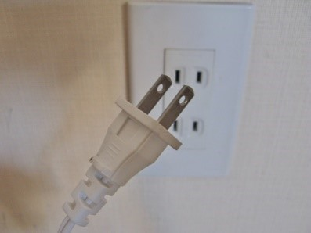

A portable plug adaptor may be necessary to use your electronic devices.

**B. Illness or injury**

The Secretariat maintains a small medical kit for routine medical issues. Several drug stores can be found near Namba Station but some medications available in your home country may only be available in Japan with a prescription.

●[COVID-19 infection prevention measures](https://www.japan.travel/en/practical-coronavirus-information/tips-for-a-safe-trip/) / Japan National Tourism Organization  
●[Information in case of illness or injury](https://www.japan.travel/en/practical-coronavirus-information/in-case-of-emergency/) / Japan National Tourism Organization

********************************************************************************

**EMERGENCY INFORMATION**

*Police*  Emergency call – 110

*Fire, Ambulance or Emergency Rescue* Emergency call – 119

********************************************************************************

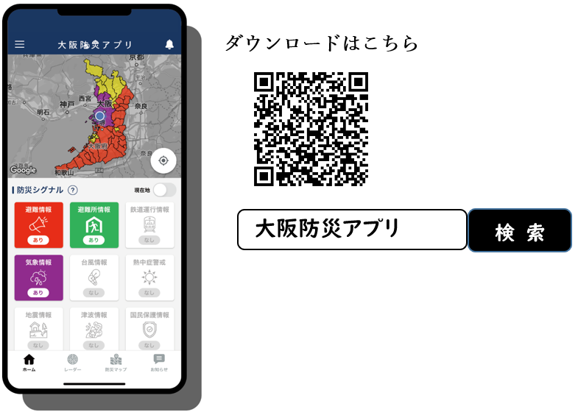

**USEFUL DISASTER PREVENTION APPLICATION**

The “Osaka Disaster Prevention Application” can be downloaded from the following page and is available in multiple languages:

<https://www.pref.osaka.lg.jp/shobobosai/odp-app/index.html>

If you have any questions regarding meeting preparations, please do not hesitate to contact Mr. Jumpei Hinata at jhinata@npfc.int or by phone at +81-80-9462-1667.

**C. WI-FI information**

Room: Hall 6, 8B, 8C, 8D

SSID: NPFC_COM09

Pass: Osaka2025

**D. Others**

There are a number of issues to highlight for you (and your delegation) to assist in your planning.

1. Organization of documents – flow between TCC and COM. We are continuing the approach deployed in COM08 whereby the document number would be assigned for the meeting that first considers it. In most cases this will be TCC08 but may include FAC07. At COM the headings used are:

a. Documents submitted directly to COM09 (IP are now listed first)

b. Documents endorsed by SC09

c. Documents endorsed by TCC08

d. Documents forwarded to COM09 from TCC08

e. NOTE: If TCC recommends adoption of a document to COM09, this document will be filed under c. Documents endorsed by TCC08. If no recommendation is agreed to at TCC08, then it will be forwarded to COM for consideration and filed under d. Documents forwarded to COM09 from TCC08

This process seemed to provide clarity to Members as to what documents were to be considered and how.

2. Please bring a water bottle with you as bulk water dispensers will be used.

**Attachment 1 – information required for visa letter**

The Fisheries Agency of Japan is willing to prepare an Invitation Letter for your visa application to attend the NPFC Meetings in Osaka, Japan (FAC07, TCC08 and/or COM09).

Please provide a list which includes the following information for each participant:

* Please provide the name as it appears on your passport.

First Name:

Last (Family) Name:

Sex (F/M):

Nationality:

Organization:

Title:

Passport Number:

Passport type (official or general):

VISA type (official visa or short-term visa):

Date of Birth:

Date of Issue:

Date of Expiry:

Passport Issuing Authority:

Period of Stay in JAPAN:

Place of Applying for VISA (Embassy or Consulate of Japan):

Arrival Airport:

Departure Airport:

Hotel Name:

Documents that you are required to submit with this attachment are below.

• A copy of passport data page

• A copy of note verbal in case of travel with official passport or general passport and official visa